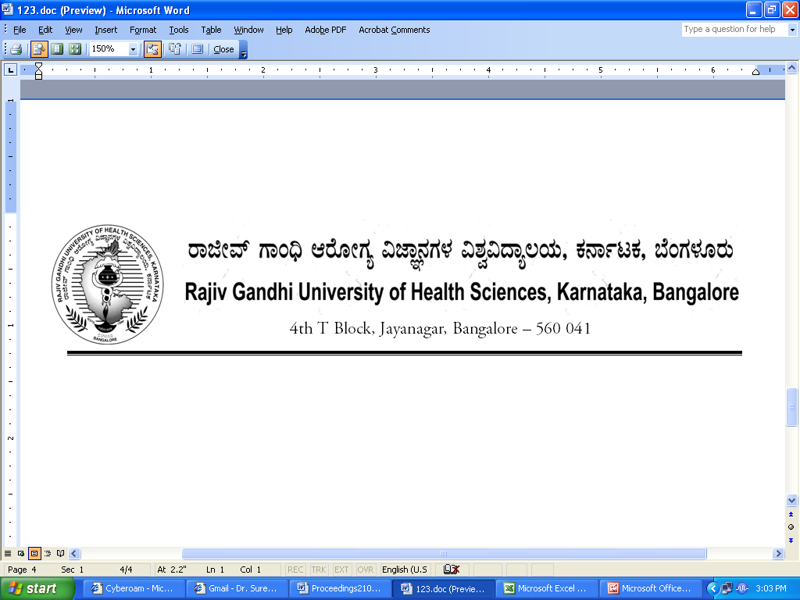
Reg(E)Exam/PG/September/October - 2018 Date: 04/07/2018

Advance Notification

Sub:- | Conduct of M.Sc Nursing, AYUSH (PG), Physiotherapy (PG) and Allied Health Sciences (PG) Course Theory Examination during September / October- 2018.
********

The Theory Examination for the below mentioned course, will tentatively commence from 18th September 2018. The detailed Time Table will be notified in due course.

 | Courses | Date
1. | M.Sc Nursing, AYUSH (PG), Physiotherapy (PG) and Allied Health Sciences (PG) | 18th September 2018

The Principals of concerned Colleges are requested to notify this on the Notice Board of their colleges for information of the students concerned.

Sd/-

Registrar (Evaluation)
To:
All the Principals of the colleges concerned for information and needful action.

Copy to:

- PA to Vice-Chancellor/Registrar/Finance Officer, RGUHS, Bangalore.
- Deputy Registrar (Admn) section for information and needful action.
- All the officers of the RGUHS, Bangalore.
- Asst. Registrar, Regional Center, Belgaum / Gulbarga.
- Guard File.

